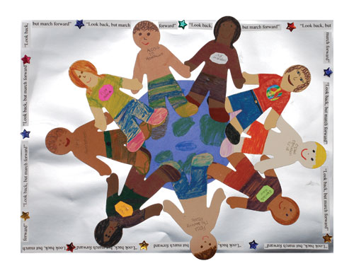
Build a
World of Peace
An Interfaith Witness

Sept. 19, 2010
3 pm – 5 pm

St. Thomas Aquinas Church
751 Waverley Street
and Heritage Park
(Waverley at Homer St), Palo Alto, CA

Come and celebrate the International Day of Peace:
"Peace Day should be devoted to commemorating and strengthening the ideals of peace both within and among all nations and peoples ..." -United Nations General Assembly
Displays: The World Peace Village, an intergenerational event where children and adults walk together the path toward peace, tolerance and understanding.
The Cost of War, an exhibit showing our lost resources and opportunities.
Activities : Sing-along, Youth choir, Children’s activities, Storytelling
Speakers: Len and Libby Traubman, creators of Jewish/Palestinian Living Room Dialogue Group and Peace Camps in the Sierra Nevada.
Rana Tomaira was born in Baghdad and has worked for over two years helping Iraqi children get medical treatment unavailable to them in Iraq.
Prayers: for peace from many faith traditions.

Sponsored by Multifaith Voices for Peace and Justice
For information, call: 650/569-3416 http://www.multifaithpeace.org
Co-sponsored by American Muslim Voice, West Bay Chapter of the Buddhist Peace Fellowship, the American Friends Service Committee, MicahsCall.org, Reach And Teach, with participation and support from First Presbyterian Church Palo Alto, First Congregational Church Palo Alto, St. Thomas Aquinas Parish, Unitarian Universalist Church of Palo Alto, Palo Alto Friends Meeting, First United Methodist Church Palo Alto, Beyt Tikkun Synagogue and the Network of Spiritual Progressives.

